**INDEX**

|  |  |  |
| --- | --- | --- |
| **Sr.No.** | **Content** | **Page No.** |
| 1 | Introduction |  |
| 2 | Calculations |  |
| 3 | Code |  |
| 4 | Output |  |
| 5 | Conclusion |  |
| 6 | Reference |  |

**INTRODUCTION**

The "Graphical Representation of Navy Day" is a captivating C programming project that brings the spirit of Navy Day to life through vibrant graphics and text animations. In this project, the code generates an impressive visual display of Navy Day celebrations with meticulous attention to detail. It features a colorful depiction of the Indian tricolor, Sindhudurg Fort, the Indian Navy flag, and patriotic messages. The code employs classic graphics techniques, including drawing shapes, filling colors, and text animations, to create an engaging and visually appealing representation of the grand Navy Day celebration. This project stands as a digital salute to the valor and patriotism of the Indian Navy.

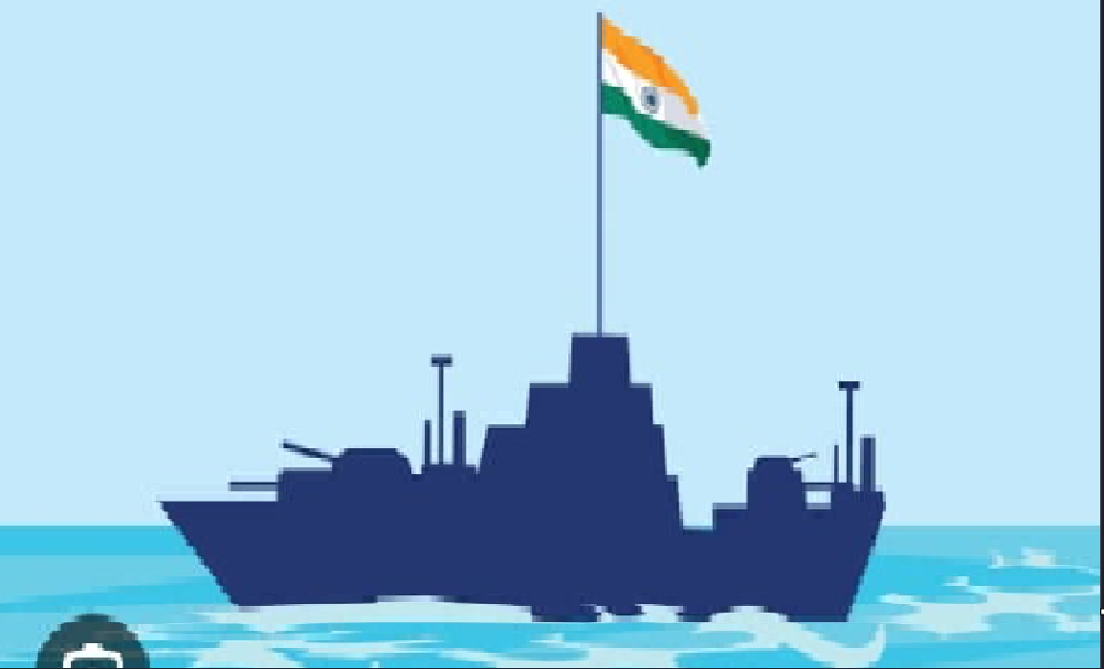

**Inspiration**

**Calculations:**

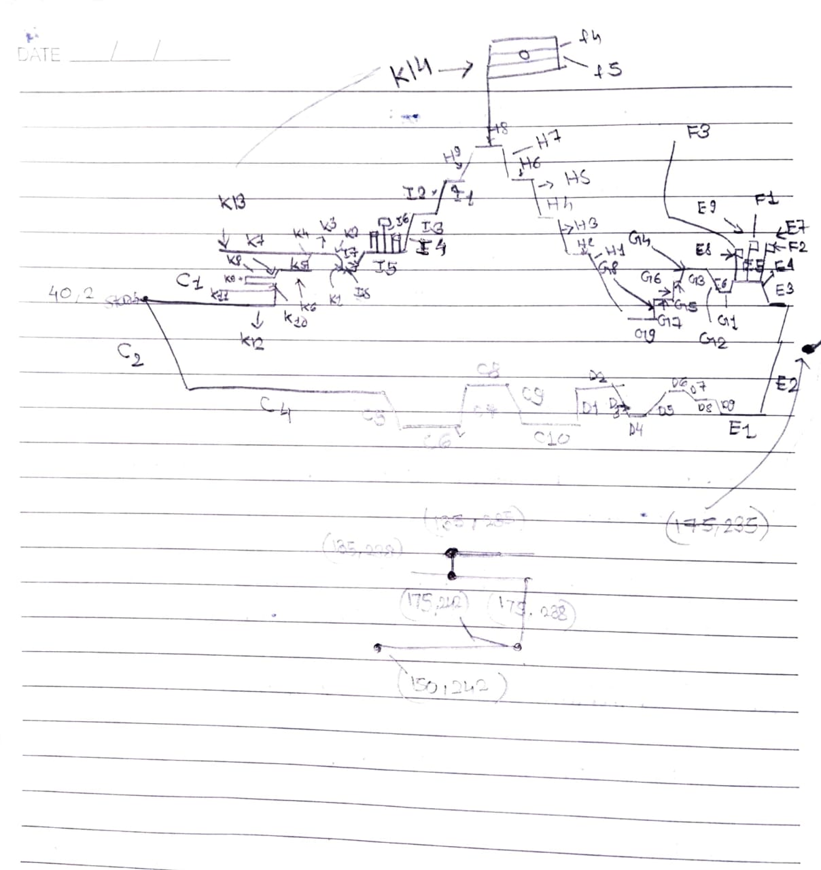

**Conclusion**

We learn the use of the standard output primitive, setcolor(), setstyle(),floodfill(),drawpoly(), fillpoly()etc. very deeply. This project was the best experience to us to explore C graphics.

This experiment is digital salute to the Indian navy on the occasion of Navy Day on Sindhudurg Fort. Jay Hind!

**Reference**

<https://developerinsider.co/c-programming-language-example-by-topics/?utm_medium=Referral&utm_source=TurboCPP>

Computer Graphics (Nirali Pub.)